# Ban502: Module 2

## Kellie McLiverty

### Multiple Linear Regression and Special Issues Assignment

Libraries needed for Assignment

library(tidyverse)

## -- Attaching packages ------------------------------------------------------------- tidyverse 1.2.1 --

## v ggplot2 3.1.0 v purrr 0.2.5  
## v tibble 1.4.2 v dplyr 0.7.8  
## v tidyr 0.8.2 v stringr 1.3.1  
## v readr 1.2.1 v forcats 0.3.0

## -- Conflicts ---------------------------------------------------------------- tidyverse_conflicts() --  
## x dplyr::filter() masks stats::filter()  
## x dplyr::lag() masks stats::lag()

library(GGally)

## Warning: package 'GGally' was built under R version 3.5.2

##   
## Attaching package: 'GGally'

## The following object is masked from 'package:dplyr':  
##   
## nasa

library(MASS)

## Warning: package 'MASS' was built under R version 3.5.2

##   
## Attaching package: 'MASS'

## The following object is masked from 'package:dplyr':  
##   
## select

library(leaps)

## Warning: package 'leaps' was built under R version 3.5.2

library(readr)

In this assignment, we will be working with an imported dataset called hour.csv. Will import this dataset into a tibble called bike using readr. We will also need to convert a few of these variables to factors, as shown in the code below.

bike <- read_csv("hour.csv")

## Parsed with column specification:  
## cols(  
## instant = col_double(),  
## dteday = col_date(format = ""),  
## season = col_double(),  
## yr = col_double(),  
## mnth = col_double(),  
## hr = col_double(),  
## holiday = col_double(),  
## weekday = col_double(),  
## workingday = col_double(),  
## weathersit = col_double(),  
## temp = col_double(),  
## atemp = col_double(),  
## hum = col_double(),  
## windspeed = col_double(),  
## casual = col_double(),  
## registered = col_double(),  
## count = col_double()  
## )

#The following lines of code are converting the variables into factors and then recoding/renaming them in the dataset   
bike = bike %>% mutate(season = as_factor(as.character(season))) %>%  
mutate(season = fct_recode(season,  
"Spring" = "1",  
"Summer" = "2",  
"Fall" = "3",  
"Winter" = "4"))  
  
bike = bike %>% mutate(yr = as_factor(as.character(yr))) %>% mutate(mnth = as_factor(as.character(mnth))) %>% mutate(hr = as_factor(as.character(hr)))  
  
bike = bike %>% mutate(holiday = as_factor(as.character(holiday))) %>%  
mutate(holiday = fct_recode(holiday,  
"NotHoliday" = "0",  
"Holiday" = "1"))  
  
bike = bike %>% mutate(workingday = as_factor(as.character(workingday))) %>%  
mutate(workingday = fct_recode(workingday,  
"NotWorkingDay" = "0",  
"WorkingDay" = "1"))  
  
bike = bike %>% mutate(weathersit = as_factor(as.character(weathersit))) %>%  
mutate(weathersit = fct_recode(weathersit,  
"NoPrecip" = "1",  
"Misty" = "2",  
"LightPrecip" = "3",  
"HeavyPrecip" = "4"))  
  
bike = bike %>% mutate(weekday = as_factor(as.character(weekday))) %>%  
mutate(weekday = fct_recode(weekday,  
"Sunday" = "0",  
"Monday" = "1",  
"Tuesday" = "2",  
"Wednesday" = "3",  
"Thursday" = "4",  
"Friday" = "5",  
"Saturday" = "6"))  
  
#Now let's check that everything converted correctly  
glimpse(bike)

## Observations: 17,379  
## Variables: 17  
## $ instant <dbl> 1, 2, 3, 4, 5, 6, 7, 8, 9, 10, 11, 12, 13, 14, 15, ...  
## $ dteday <date> 2011-01-01, 2011-01-01, 2011-01-01, 2011-01-01, 20...  
## $ season <fct> Spring, Spring, Spring, Spring, Spring, Spring, Spr...  
## $ yr <fct> 0, 0, 0, 0, 0, 0, 0, 0, 0, 0, 0, 0, 0, 0, 0, 0, 0, ...  
## $ mnth <fct> 1, 1, 1, 1, 1, 1, 1, 1, 1, 1, 1, 1, 1, 1, 1, 1, 1, ...  
## $ hr <fct> 0, 1, 2, 3, 4, 5, 6, 7, 8, 9, 10, 11, 12, 13, 14, 1...  
## $ holiday <fct> NotHoliday, NotHoliday, NotHoliday, NotHoliday, Not...  
## $ weekday <fct> Saturday, Saturday, Saturday, Saturday, Saturday, S...  
## $ workingday <fct> NotWorkingDay, NotWorkingDay, NotWorkingDay, NotWor...  
## $ weathersit <fct> NoPrecip, NoPrecip, NoPrecip, NoPrecip, NoPrecip, M...  
## $ temp <dbl> 0.24, 0.22, 0.22, 0.24, 0.24, 0.24, 0.22, 0.20, 0.2...  
## $ atemp <dbl> 0.2879, 0.2727, 0.2727, 0.2879, 0.2879, 0.2576, 0.2...  
## $ hum <dbl> 0.81, 0.80, 0.80, 0.75, 0.75, 0.75, 0.80, 0.86, 0.7...  
## $ windspeed <dbl> 0.0000, 0.0000, 0.0000, 0.0000, 0.0000, 0.0896, 0.0...  
## $ casual <dbl> 3, 8, 5, 3, 0, 0, 2, 1, 1, 8, 12, 26, 29, 47, 35, 4...  
## $ registered <dbl> 13, 32, 27, 10, 1, 1, 0, 2, 7, 6, 24, 30, 55, 47, 7...  
## $ count <dbl> 16, 40, 32, 13, 1, 1, 2, 3, 8, 14, 36, 56, 84, 94, ...

Let’s take a look at which quantitative variables appears to be best correlated with “count” using ggcorr and ggpairs. To do this with ggpairs, we exclude the qualitative variable columns of the data by only specifying the needed columns. By reviewing the correlation charts, we can see that the Casual variable appears to be the best correlated variable to Count with a value of 0.695, after excluding registered as an option.

ggcorr(bike, label = "TRUE", label_round = 2) #Correlation diagram excluding categorical variables

## Warning in ggcorr(bike, label = "TRUE", label_round = 2): data in column(s)  
## 'dteday', 'season', 'yr', 'mnth', 'hr', 'holiday', 'weekday', 'workingday',  
## 'weathersit' are not numeric and were ignored

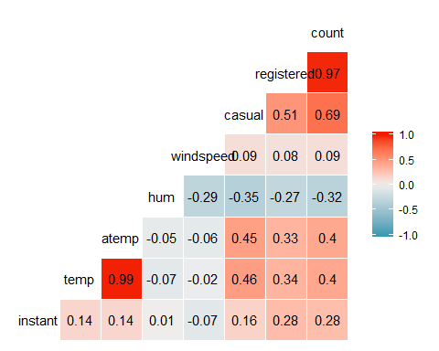

ggpairs(bike, columns = c(1, 10:17)) #Select columns of quantitative data

## `stat_bin()` using `bins = 30`. Pick better value with `binwidth`.  
## `stat_bin()` using `bins = 30`. Pick better value with `binwidth`.  
## `stat_bin()` using `bins = 30`. Pick better value with `binwidth`.  
## `stat_bin()` using `bins = 30`. Pick better value with `binwidth`.  
## `stat_bin()` using `bins = 30`. Pick better value with `binwidth`.  
## `stat_bin()` using `bins = 30`. Pick better value with `binwidth`.  
## `stat_bin()` using `bins = 30`. Pick better value with `binwidth`.  
## `stat_bin()` using `bins = 30`. Pick better value with `binwidth`.

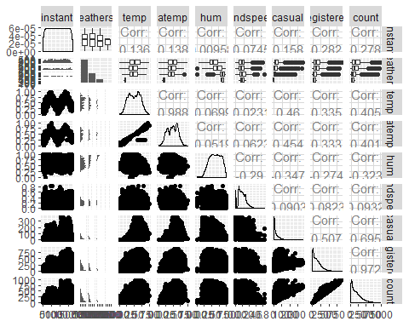

As we use correlation to assess the relationship between a categorical predictor variable and our response variable, Count, we must take a look at how these variables graph to determine if they have a relationship with the response variable. Using these boxplot based analysis, we can find which variables we should use to plot a linear regression model.

ggplot(bike,aes(x=hr,y=count)) + geom_boxplot() #hr does have an effect on count

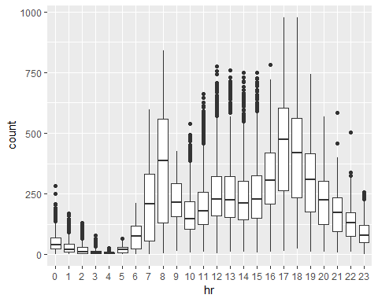

ggplot(bike,aes(x=yr,y=count)) + geom_boxplot()

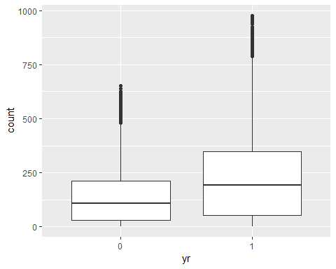

ggplot(bike,aes(x=mnth,y=count)) + geom_boxplot()

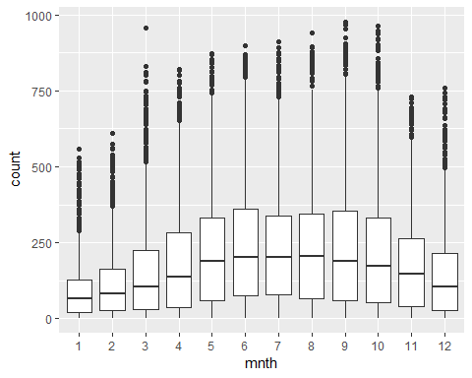

ggplot(bike,aes(x=season,y=count)) + geom_boxplot()

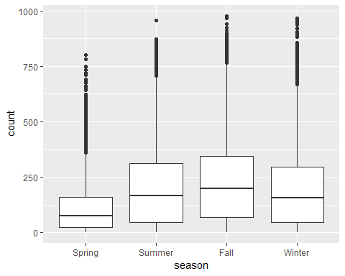

ggplot(bike,aes(x=holiday,y=count)) + geom_boxplot()

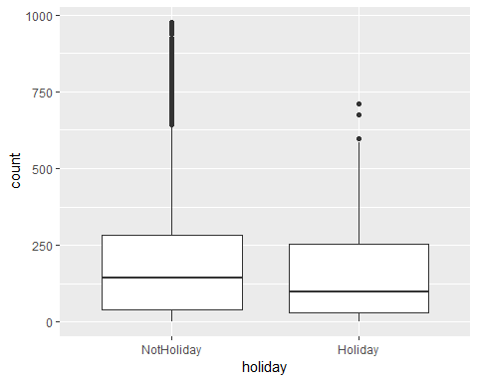

ggplot(bike,aes(x=weekday,y=count)) + geom_boxplot()

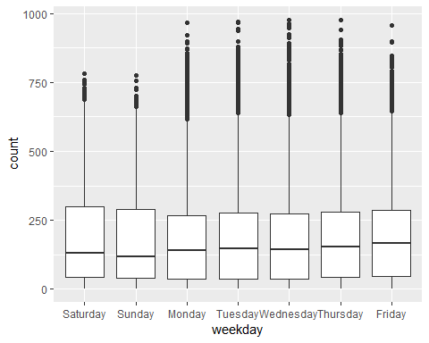

ggplot(bike,aes(x=workingday,y=count)) + geom_boxplot()

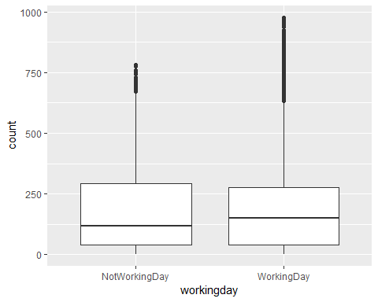

ggplot(bike,aes(x=weathersit,y=count)) + geom_boxplot()

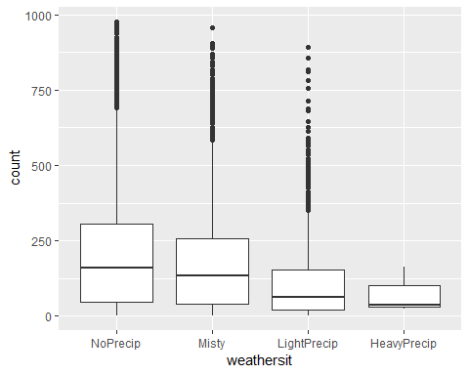

1.) In our fist boxplot, we can see a clear relationship that hr has with count. The hour changes the count rather significantly, and should be shown in our linear regression model to see how much.

2.) Looking at this plot, we can see that count rose by quite a bit in year 1 as compared to year 0. We could say that the year has an impact on the count, but I’m not convinced it is a significant predictor of count as compared to the other variables.

3.) Much like hr, we can see from this boxplot there is some kind of relationship between mnth and count. It may not be as strong as “hr”, but this variable clearly does have some effect on count.

4.) In this boxplot, we can see anoticeable change in the count between the seasons. While there might be specific reasons behind this, at a surface level there does appear to be a relationship between these variables, and should be explored using a linear regression.

5.) Again, while reviewing this boxplot, there’s no real noticeable changes in count between NotHoliday and Holiday, as such I do not see Holiday as much of a predictor of count.

6.) Looking at the data of count based by weekday, we can see a fairly similar degree across each boxplot. Nothing really stands out or changes much between each day, as such I don’t see weekday as much of a predictor variable for count.

7.) When reviewing this boxplot, there is not much of a change in the data based on the workingday variable. These boxplots are fairly similar, with just a slight increase on WorkingDays; However, this does not seem to have a significant impact on count. As such, I do not believe this variable should be used for the regression model.

8.) Looking at this boxplot, we can clearly see that weathersit has a pretty big impact on count. As the weather goes from NoPrecip to HeavyPrecip, we can see a decrease in the Count. From this we can infer that these variables have a negative relationship.

### Creating Multiple Regression Models: Forward Stepwise

To begin with creating our forward stepwise model, we start with creating bothe full and empty models to work with. Then we will review the summary to see which variables were included in the model.

bike2 = bike %>% dplyr::select(-c(instant, dteday, registered, casual)) #removes these variable from the dataset  
  
ggplot(bike2, aes(x=count)) + geom_histogram() + theme_bw() #a look at our response variable.

## `stat_bin()` using `bins = 30`. Pick better value with `binwidth`.

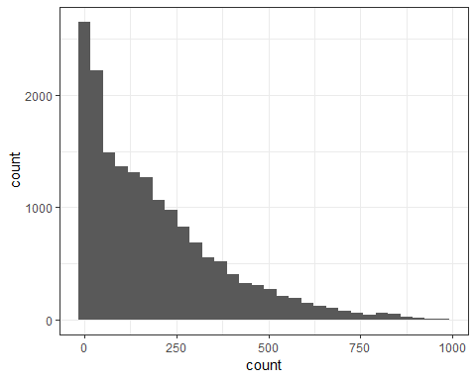

ggcorr(bike2, label = "TRUE", label_round = 2) #looking at correlation once again

## Warning in ggcorr(bike2, label = "TRUE", label_round = 2): data in  
## column(s) 'season', 'yr', 'mnth', 'hr', 'holiday', 'weekday', 'workingday',  
## 'weathersit' are not numeric and were ignored

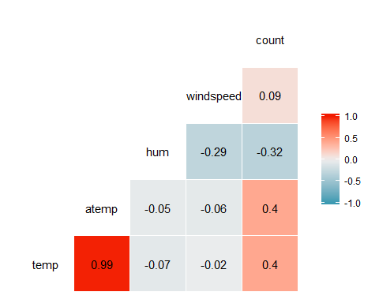

#preparing for our model by creating a full and empty model  
allmod = lm(count ~., bike2) #use the ~. to include all predictors rather than typing them all in  
summary(allmod)

##   
## Call:  
## lm(formula = count ~ ., data = bike2)  
##   
## Residuals:  
## Min 1Q Median 3Q Max   
## -393.87 -60.66 -7.96 51.31 439.18   
##   
## Coefficients: (1 not defined because of singularities)  
## Estimate Std. Error t value Pr(>|t|)   
## (Intercept) -67.542 6.612 -10.216 < 2e-16 ***  
## seasonSummer 38.178 4.856 7.862 4.00e-15 ***  
## seasonFall 32.055 5.749 5.575 2.51e-08 ***  
## seasonWinter 67.994 4.882 13.928 < 2e-16 ***  
## yr1 85.431 1.563 54.658 < 2e-16 ***  
## mnth2 3.426 3.920 0.874 0.38219   
## mnth3 14.299 4.407 3.244 0.00118 **   
## mnth4 6.230 6.548 0.951 0.34144   
## mnth5 20.657 7.007 2.948 0.00320 **   
## mnth6 6.238 7.205 0.866 0.38662   
## mnth7 -13.269 8.082 -1.642 0.10065   
## mnth8 7.897 7.879 1.002 0.31622   
## mnth9 32.269 7.001 4.609 4.07e-06 ***  
## mnth10 15.843 6.483 2.444 0.01455 *   
## mnth11 -9.840 6.238 -1.577 0.11474   
## mnth12 -6.256 4.954 -1.263 0.20672   
## hr1 -17.294 5.345 -3.236 0.00122 **   
## hr2 -26.369 5.364 -4.916 8.91e-07 ***  
## hr3 -37.112 5.403 -6.869 6.67e-12 ***  
## hr4 -40.263 5.408 -7.445 1.01e-13 ***  
## hr5 -23.501 5.373 -4.374 1.23e-05 ***  
## hr6 35.393 5.359 6.605 4.10e-11 ***  
## hr7 170.418 5.348 31.864 < 2e-16 ***  
## hr8 310.801 5.342 58.183 < 2e-16 ***  
## hr9 163.101 5.347 30.501 < 2e-16 ***  
## hr10 108.444 5.370 20.196 < 2e-16 ***  
## hr11 133.843 5.409 24.742 < 2e-16 ***  
## hr12 173.142 5.456 31.735 < 2e-16 ***  
## hr13 168.102 5.494 30.600 < 2e-16 ***  
## hr14 152.249 5.525 27.558 < 2e-16 ***  
## hr15 161.707 5.535 29.213 < 2e-16 ***  
## hr16 223.834 5.524 40.522 < 2e-16 ***  
## hr17 377.535 5.491 68.750 < 2e-16 ***  
## hr18 345.587 5.455 63.350 < 2e-16 ***  
## hr19 236.919 5.404 43.841 < 2e-16 ***  
## hr20 157.293 5.375 29.266 < 2e-16 ***  
## hr21 107.840 5.353 20.147 < 2e-16 ***  
## hr22 70.907 5.343 13.272 < 2e-16 ***  
## hr23 32.112 5.338 6.015 1.83e-09 ***  
## holidayHoliday -26.228 4.881 -5.374 7.81e-08 ***  
## weekdaySunday -16.089 2.878 -5.591 2.30e-08 ***  
## weekdayMonday -6.814 2.970 -2.294 0.02180 *   
## weekdayTuesday -5.240 2.899 -1.807 0.07071 .   
## weekdayWednesday -2.464 2.894 -0.851 0.39469   
## weekdayThursday -2.940 2.892 -1.016 0.30947   
## weekdayFriday 1.356 2.885 0.470 0.63823   
## workingdayWorkingDay NA NA NA NA   
## weathersitMisty -10.409 1.920 -5.421 6.00e-08 ***  
## weathersitLightPrecip -65.189 3.236 -20.145 < 2e-16 ***  
## weathersitHeavyPrecip -62.580 58.893 -1.063 0.28797   
## temp 116.384 29.513 3.943 8.06e-05 ***  
## atemp 127.975 30.624 4.179 2.94e-05 ***  
## hum -82.802 5.554 -14.909 < 2e-16 ***  
## windspeed -29.167 7.052 -4.136 3.55e-05 ***  
## ---  
## Signif. codes: 0 '***' 0.001 '**' 0.01 '*' 0.05 '.' 0.1 ' ' 1  
##   
## Residual standard error: 101.7 on 17326 degrees of freedom  
## Multiple R-squared: 0.6864, Adjusted R-squared: 0.6854   
## F-statistic: 729.1 on 52 and 17326 DF, p-value: < 2.2e-16

emptymod = lm(count ~1, bike2) #use ~1 to build an empty model  
summary(emptymod)

##   
## Call:  
## lm(formula = count ~ 1, data = bike2)  
##   
## Residuals:  
## Min 1Q Median 3Q Max   
## -188.46 -149.46 -47.46 91.54 787.54   
##   
## Coefficients:  
## Estimate Std. Error t value Pr(>|t|)   
## (Intercept) 189.463 1.376 137.7 <2e-16 ***  
## ---  
## Signif. codes: 0 '***' 0.001 '**' 0.01 '*' 0.05 '.' 0.1 ' ' 1  
##   
## Residual standard error: 181.4 on 17378 degrees of freedom

#forward stepwise model  
forwardmod = stepAIC(emptymod, direction = "forward", scope=list(upper=allmod,lower=emptymod), trace = TRUE) #trace = TRUE shows how the model is built (which variables are added)

## Start: AIC=180764.7  
## count ~ 1  
##   
## Df Sum of Sq RSS AIC  
## + hr 23 286734681 285026910 168713  
## + temp 1 93677759 478083832 177657  
## + atemp 1 91907421 479854170 177721  
## + hum 1 59618351 512143240 178853  
## + mnth 11 42909976 528851615 179431  
## + season 3 37729358 534032233 179584  
## + yr 1 35876722 535884870 179641  
## + weathersit 3 12285030 559476561 180393  
## + windspeed 1 4970060 566791531 180615  
## + holiday 1 546889 571214702 180750  
## + workingday 1 524387 571237204 180751  
## + weekday 6 687929 571073662 180756  
## <none> 571761591 180765  
##   
## Step: AIC=168712.5  
## count ~ hr  
##   
## Df Sum of Sq RSS AIC  
## + atemp 1 50518941 234507969 165324  
## + temp 1 50101685 234925225 165355  
## + mnth 11 44822160 240204750 165761  
## + season 3 39619754 245407156 166117  
## + yr 1 36875130 248151780 166307  
## + weathersit 3 13766672 271260238 167858  
## + hum 1 4924310 280102600 168412  
## + windspeed 1 1476211 283550699 168624  
## + holiday 1 561784 284465126 168680  
## + weekday 6 719530 284307380 168681  
## + workingday 1 485366 284541544 168685  
## <none> 285026910 168713  
##   
## Step: AIC=165324  
## count ~ hr + atemp  
##   
## Df Sum of Sq RSS AIC  
## + yr 1 33463769 201044200 162650  
## + weathersit 3 9227265 225280704 164632  
## + hum 1 7008684 227499285 164799  
## + season 3 6580442 227927527 164835  
## + mnth 11 5854560 228653409 164907  
## + weekday 6 607638 233900331 165291  
## + holiday 1 274006 234233963 165306  
## + temp 1 152153 234355816 165315  
## + windspeed 1 120557 234387412 165317  
## + workingday 1 90170 234417799 165319  
## <none> 234507969 165324  
##   
## Step: AIC=162650.2  
## count ~ hr + atemp + yr  
##   
## Df Sum of Sq RSS AIC  
## + weathersit 3 8408358 192635842 161914  
## + season 3 7190305 193853896 162023  
## + mnth 11 6486062 194558138 162102  
## + hum 1 4341837 196702363 162273  
## + weekday 6 641648 200402552 162607  
## + holiday 1 324763 200719438 162624  
## + windspeed 1 109311 200934889 162643  
## + workingday 1 106404 200937797 162643  
## + temp 1 91735 200952465 162644  
## <none> 201044200 162650  
##   
## Step: AIC=161913.7  
## count ~ hr + atemp + yr + weathersit  
##   
## Df Sum of Sq RSS AIC  
## + season 3 7771024 184864818 161204  
## + mnth 11 7464989 185170852 161249  
## + hum 1 805099 191830743 161843  
## + weekday 6 686172 191949670 161864  
## + holiday 1 413536 192222305 161878  
## + workingday 1 212428 192423414 161897  
## + temp 1 134482 192501360 161904  
## + windspeed 1 44407 192591435 161912  
## <none> 192635842 161914  
##   
## Step: AIC=161204.1  
## count ~ hr + atemp + yr + weathersit + season  
##   
## Df Sum of Sq RSS AIC  
## + mnth 11 2051323 182813495 161032  
## + hum 1 1810161 183054657 161035  
## + weekday 6 704303 184160515 161150  
## + holiday 1 392702 184472116 161169  
## + temp 1 352584 184512234 161173  
## + workingday 1 214973 184649845 161186  
## <none> 184864818 161204  
## + windspeed 1 158 184864660 161206  
##   
## Step: AIC=161032.2  
## count ~ hr + atemp + yr + weathersit + season + mnth  
##   
## Df Sum of Sq RSS AIC  
## + hum 1 2356411 180457084 160809  
## + weekday 6 692672 182120823 160978  
## + holiday 1 312321 182501174 161004  
## + temp 1 233052 182580443 161012  
## + workingday 1 203953 182609542 161015  
## <none> 182813495 161032  
## + windspeed 1 68 182813428 161034  
##   
## Step: AIC=160808.7  
## count ~ hr + atemp + yr + weathersit + season + mnth + hum  
##   
## Df Sum of Sq RSS AIC  
## + weekday 6 581105 179875980 160765  
## + holiday 1 322997 180134087 160780  
## + workingday 1 194139 180262945 160792  
## + windspeed 1 114287 180342797 160800  
## + temp 1 100025 180357059 160801  
## <none> 180457084 160809  
##   
## Step: AIC=160764.7  
## count ~ hr + atemp + yr + weathersit + season + mnth + hum +   
## weekday  
##   
## Df Sum of Sq RSS AIC  
## + holiday 1 274717 179601263 160740  
## + workingday 1 274717 179601263 160740  
## + windspeed 1 112085 179763895 160756  
## + temp 1 77171 179798809 160759  
## <none> 179875980 160765  
##   
## Step: AIC=160740.1  
## count ~ hr + atemp + yr + weathersit + season + mnth + hum +   
## weekday + holiday  
##   
## Df Sum of Sq RSS AIC  
## + windspeed 1 111562 179489701 160731  
## + temp 1 95460 179505803 160733  
## <none> 179601263 160740  
##   
## Step: AIC=160731.3  
## count ~ hr + atemp + yr + weathersit + season + mnth + hum +   
## weekday + holiday + windspeed  
##   
## Df Sum of Sq RSS AIC  
## + temp 1 160954 179328746 160718  
## <none> 179489701 160731  
##   
## Step: AIC=160717.7  
## count ~ hr + atemp + yr + weathersit + season + mnth + hum +   
## weekday + holiday + windspeed + temp  
##   
## Df Sum of Sq RSS AIC  
## <none> 179328746 160718

summary(forwardmod)

##   
## Call:  
## lm(formula = count ~ hr + atemp + yr + weathersit + season +   
## mnth + hum + weekday + holiday + windspeed + temp, data = bike2)  
##   
## Residuals:  
## Min 1Q Median 3Q Max   
## -393.87 -60.66 -7.96 51.31 439.18   
##   
## Coefficients:  
## Estimate Std. Error t value Pr(>|t|)   
## (Intercept) -67.542 6.612 -10.216 < 2e-16 ***  
## hr1 -17.294 5.345 -3.236 0.00122 **   
## hr2 -26.369 5.364 -4.916 8.91e-07 ***  
## hr3 -37.112 5.403 -6.869 6.67e-12 ***  
## hr4 -40.263 5.408 -7.445 1.01e-13 ***  
## hr5 -23.501 5.373 -4.374 1.23e-05 ***  
## hr6 35.393 5.359 6.605 4.10e-11 ***  
## hr7 170.418 5.348 31.864 < 2e-16 ***  
## hr8 310.801 5.342 58.183 < 2e-16 ***  
## hr9 163.101 5.347 30.501 < 2e-16 ***  
## hr10 108.444 5.370 20.196 < 2e-16 ***  
## hr11 133.843 5.409 24.742 < 2e-16 ***  
## hr12 173.142 5.456 31.735 < 2e-16 ***  
## hr13 168.102 5.494 30.600 < 2e-16 ***  
## hr14 152.249 5.525 27.558 < 2e-16 ***  
## hr15 161.707 5.535 29.213 < 2e-16 ***  
## hr16 223.834 5.524 40.522 < 2e-16 ***  
## hr17 377.535 5.491 68.750 < 2e-16 ***  
## hr18 345.587 5.455 63.350 < 2e-16 ***  
## hr19 236.919 5.404 43.841 < 2e-16 ***  
## hr20 157.293 5.375 29.266 < 2e-16 ***  
## hr21 107.840 5.353 20.147 < 2e-16 ***  
## hr22 70.907 5.343 13.272 < 2e-16 ***  
## hr23 32.112 5.338 6.015 1.83e-09 ***  
## atemp 127.975 30.624 4.179 2.94e-05 ***  
## yr1 85.431 1.563 54.658 < 2e-16 ***  
## weathersitMisty -10.409 1.920 -5.421 6.00e-08 ***  
## weathersitLightPrecip -65.189 3.236 -20.145 < 2e-16 ***  
## weathersitHeavyPrecip -62.580 58.893 -1.063 0.28797   
## seasonSummer 38.178 4.856 7.862 4.00e-15 ***  
## seasonFall 32.055 5.749 5.575 2.51e-08 ***  
## seasonWinter 67.994 4.882 13.928 < 2e-16 ***  
## mnth2 3.426 3.920 0.874 0.38219   
## mnth3 14.299 4.407 3.244 0.00118 **   
## mnth4 6.230 6.548 0.951 0.34144   
## mnth5 20.657 7.007 2.948 0.00320 **   
## mnth6 6.238 7.205 0.866 0.38662   
## mnth7 -13.269 8.082 -1.642 0.10065   
## mnth8 7.897 7.879 1.002 0.31622   
## mnth9 32.269 7.001 4.609 4.07e-06 ***  
## mnth10 15.843 6.483 2.444 0.01455 *   
## mnth11 -9.840 6.238 -1.577 0.11474   
## mnth12 -6.256 4.954 -1.263 0.20672   
## hum -82.802 5.554 -14.909 < 2e-16 ***  
## weekdaySunday -16.089 2.878 -5.591 2.30e-08 ***  
## weekdayMonday -6.814 2.970 -2.294 0.02180 *   
## weekdayTuesday -5.240 2.899 -1.807 0.07071 .   
## weekdayWednesday -2.464 2.894 -0.851 0.39469   
## weekdayThursday -2.940 2.892 -1.016 0.30947   
## weekdayFriday 1.356 2.885 0.470 0.63823   
## holidayHoliday -26.228 4.881 -5.374 7.81e-08 ***  
## windspeed -29.167 7.052 -4.136 3.55e-05 ***  
## temp 116.384 29.513 3.943 8.06e-05 ***  
## ---  
## Signif. codes: 0 '***' 0.001 '**' 0.01 '*' 0.05 '.' 0.1 ' ' 1  
##   
## Residual standard error: 101.7 on 17326 degrees of freedom  
## Multiple R-squared: 0.6864, Adjusted R-squared: 0.6854   
## F-statistic: 729.1 on 52 and 17326 DF, p-value: < 2.2e-16

Looking over the summary of our forward stepwise model, we can see that the model includes hr, atemp, yr1, weathersit,Season, mnth exluding mnth1, hum, weekday, windspeed, and temp variables.

While reviewing th model, it did reflect many of the variables I considered to have common sense relationships with count. We can also see a number of significant relationships between these variables and count. Another thing to note is our AIC is smaller than our RSS, and the smaller the AIC the better.

We can further judge this model by looking at our Adjusted R-squared value. The Adjusted R-squared is close to 1 at a value of 0.6854; Therefore, we can imply that this is a good model of variables to predict count.

### Creating Multiple Regression Models: Backward Stepwise

backmod = stepAIC(allmod, direction = "backward", trace = TRUE) #trace = TRUE shows how the model is built (which variables are removed)

## Start: AIC=160717.7  
## count ~ season + yr + mnth + hr + holiday + weekday + workingday +   
## weathersit + temp + atemp + hum + windspeed  
##   
##   
## Step: AIC=160717.7  
## count ~ season + yr + mnth + hr + holiday + weekday + weathersit +   
## temp + atemp + hum + windspeed  
##   
## Df Sum of Sq RSS AIC  
## <none> 179328746 160718  
## - temp 1 160954 179489701 160731  
## - windspeed 1 177057 179505803 160733  
## - atemp 1 180751 179509498 160733  
## - holiday 1 298893 179627639 160745  
## - weekday 6 498795 179827541 160754  
## - mnth 11 2426171 181754917 160929  
## - hum 1 2300667 181629413 160937  
## - season 3 2398467 181727213 160943  
## - weathersit 3 4208731 183537478 161115  
## - yr 1 30920851 210249597 163480  
## - hr 23 196741474 376070220 173542

summary(backmod)

##   
## Call:  
## lm(formula = count ~ season + yr + mnth + hr + holiday + weekday +   
## weathersit + temp + atemp + hum + windspeed, data = bike2)  
##   
## Residuals:  
## Min 1Q Median 3Q Max   
## -393.87 -60.66 -7.96 51.31 439.18   
##   
## Coefficients:  
## Estimate Std. Error t value Pr(>|t|)   
## (Intercept) -67.542 6.612 -10.216 < 2e-16 ***  
## seasonSummer 38.178 4.856 7.862 4.00e-15 ***  
## seasonFall 32.055 5.749 5.575 2.51e-08 ***  
## seasonWinter 67.994 4.882 13.928 < 2e-16 ***  
## yr1 85.431 1.563 54.658 < 2e-16 ***  
## mnth2 3.426 3.920 0.874 0.38219   
## mnth3 14.299 4.407 3.244 0.00118 **   
## mnth4 6.230 6.548 0.951 0.34144   
## mnth5 20.657 7.007 2.948 0.00320 **   
## mnth6 6.238 7.205 0.866 0.38662   
## mnth7 -13.269 8.082 -1.642 0.10065   
## mnth8 7.897 7.879 1.002 0.31622   
## mnth9 32.269 7.001 4.609 4.07e-06 ***  
## mnth10 15.843 6.483 2.444 0.01455 *   
## mnth11 -9.840 6.238 -1.577 0.11474   
## mnth12 -6.256 4.954 -1.263 0.20672   
## hr1 -17.294 5.345 -3.236 0.00122 **   
## hr2 -26.369 5.364 -4.916 8.91e-07 ***  
## hr3 -37.112 5.403 -6.869 6.67e-12 ***  
## hr4 -40.263 5.408 -7.445 1.01e-13 ***  
## hr5 -23.501 5.373 -4.374 1.23e-05 ***  
## hr6 35.393 5.359 6.605 4.10e-11 ***  
## hr7 170.418 5.348 31.864 < 2e-16 ***  
## hr8 310.801 5.342 58.183 < 2e-16 ***  
## hr9 163.101 5.347 30.501 < 2e-16 ***  
## hr10 108.444 5.370 20.196 < 2e-16 ***  
## hr11 133.843 5.409 24.742 < 2e-16 ***  
## hr12 173.142 5.456 31.735 < 2e-16 ***  
## hr13 168.102 5.494 30.600 < 2e-16 ***  
## hr14 152.249 5.525 27.558 < 2e-16 ***  
## hr15 161.707 5.535 29.213 < 2e-16 ***  
## hr16 223.834 5.524 40.522 < 2e-16 ***  
## hr17 377.535 5.491 68.750 < 2e-16 ***  
## hr18 345.587 5.455 63.350 < 2e-16 ***  
## hr19 236.919 5.404 43.841 < 2e-16 ***  
## hr20 157.293 5.375 29.266 < 2e-16 ***  
## hr21 107.840 5.353 20.147 < 2e-16 ***  
## hr22 70.907 5.343 13.272 < 2e-16 ***  
## hr23 32.112 5.338 6.015 1.83e-09 ***  
## holidayHoliday -26.228 4.881 -5.374 7.81e-08 ***  
## weekdaySunday -16.089 2.878 -5.591 2.30e-08 ***  
## weekdayMonday -6.814 2.970 -2.294 0.02180 *   
## weekdayTuesday -5.240 2.899 -1.807 0.07071 .   
## weekdayWednesday -2.464 2.894 -0.851 0.39469   
## weekdayThursday -2.940 2.892 -1.016 0.30947   
## weekdayFriday 1.356 2.885 0.470 0.63823   
## weathersitMisty -10.409 1.920 -5.421 6.00e-08 ***  
## weathersitLightPrecip -65.189 3.236 -20.145 < 2e-16 ***  
## weathersitHeavyPrecip -62.580 58.893 -1.063 0.28797   
## temp 116.384 29.513 3.943 8.06e-05 ***  
## atemp 127.975 30.624 4.179 2.94e-05 ***  
## hum -82.802 5.554 -14.909 < 2e-16 ***  
## windspeed -29.167 7.052 -4.136 3.55e-05 ***  
## ---  
## Signif. codes: 0 '***' 0.001 '**' 0.01 '*' 0.05 '.' 0.1 ' ' 1  
##   
## Residual standard error: 101.7 on 17326 degrees of freedom  
## Multiple R-squared: 0.6864, Adjusted R-squared: 0.6854   
## F-statistic: 729.1 on 52 and 17326 DF, p-value: < 2.2e-16

Looking at the summary of the backwards setpwise model, we can see a few similarities between the models. The backward stepwise model included temp, windspeed, atemp, holiday, weekday, mnth, hum, season, weathersit, yr, and hr. It’s interesting to note that the WorkingDay variable was kicked from the Backward stepwise model, while it wasn’t included in the Forward Stepwise model to start. Workingday is still represented in the data through the weekday variable, as we can imply a typical workday schedule of Monday through Friday. The weekend days, or non-working days, showed to have a significant relationship with count and could be used as a prediction variable.

### Modeling Future Years with Forward Stepwise

bike = bike %>% mutate(yr = as.integer(yr)-1)  
bike3 = bike %>% dplyr::select(-c(instant, dteday, registered, casual)) #new dataset to build models  
  
#preparing for our model by creating a full and empty model  
allmod1 = lm(count ~., bike3) #use the ~. to include all predictors rather than typing them all in  
summary(allmod1)

##   
## Call:  
## lm(formula = count ~ ., data = bike3)  
##   
## Residuals:  
## Min 1Q Median 3Q Max   
## -393.87 -60.66 -7.96 51.31 439.18   
##   
## Coefficients: (1 not defined because of singularities)  
## Estimate Std. Error t value Pr(>|t|)   
## (Intercept) -67.542 6.612 -10.216 < 2e-16 ***  
## seasonSummer 38.178 4.856 7.862 4.00e-15 ***  
## seasonFall 32.055 5.749 5.575 2.51e-08 ***  
## seasonWinter 67.994 4.882 13.928 < 2e-16 ***  
## yr 85.431 1.563 54.658 < 2e-16 ***  
## mnth2 3.426 3.920 0.874 0.38219   
## mnth3 14.299 4.407 3.244 0.00118 **   
## mnth4 6.230 6.548 0.951 0.34144   
## mnth5 20.657 7.007 2.948 0.00320 **   
## mnth6 6.238 7.205 0.866 0.38662   
## mnth7 -13.269 8.082 -1.642 0.10065   
## mnth8 7.897 7.879 1.002 0.31622   
## mnth9 32.269 7.001 4.609 4.07e-06 ***  
## mnth10 15.843 6.483 2.444 0.01455 *   
## mnth11 -9.840 6.238 -1.577 0.11474   
## mnth12 -6.256 4.954 -1.263 0.20672   
## hr1 -17.294 5.345 -3.236 0.00122 **   
## hr2 -26.369 5.364 -4.916 8.91e-07 ***  
## hr3 -37.112 5.403 -6.869 6.67e-12 ***  
## hr4 -40.263 5.408 -7.445 1.01e-13 ***  
## hr5 -23.501 5.373 -4.374 1.23e-05 ***  
## hr6 35.393 5.359 6.605 4.10e-11 ***  
## hr7 170.418 5.348 31.864 < 2e-16 ***  
## hr8 310.801 5.342 58.183 < 2e-16 ***  
## hr9 163.101 5.347 30.501 < 2e-16 ***  
## hr10 108.444 5.370 20.196 < 2e-16 ***  
## hr11 133.843 5.409 24.742 < 2e-16 ***  
## hr12 173.142 5.456 31.735 < 2e-16 ***  
## hr13 168.102 5.494 30.600 < 2e-16 ***  
## hr14 152.249 5.525 27.558 < 2e-16 ***  
## hr15 161.707 5.535 29.213 < 2e-16 ***  
## hr16 223.834 5.524 40.522 < 2e-16 ***  
## hr17 377.535 5.491 68.750 < 2e-16 ***  
## hr18 345.587 5.455 63.350 < 2e-16 ***  
## hr19 236.919 5.404 43.841 < 2e-16 ***  
## hr20 157.293 5.375 29.266 < 2e-16 ***  
## hr21 107.840 5.353 20.147 < 2e-16 ***  
## hr22 70.907 5.343 13.272 < 2e-16 ***  
## hr23 32.112 5.338 6.015 1.83e-09 ***  
## holidayHoliday -26.228 4.881 -5.374 7.81e-08 ***  
## weekdaySunday -16.089 2.878 -5.591 2.30e-08 ***  
## weekdayMonday -6.814 2.970 -2.294 0.02180 *   
## weekdayTuesday -5.240 2.899 -1.807 0.07071 .   
## weekdayWednesday -2.464 2.894 -0.851 0.39469   
## weekdayThursday -2.940 2.892 -1.016 0.30947   
## weekdayFriday 1.356 2.885 0.470 0.63823   
## workingdayWorkingDay NA NA NA NA   
## weathersitMisty -10.409 1.920 -5.421 6.00e-08 ***  
## weathersitLightPrecip -65.189 3.236 -20.145 < 2e-16 ***  
## weathersitHeavyPrecip -62.580 58.893 -1.063 0.28797   
## temp 116.384 29.513 3.943 8.06e-05 ***  
## atemp 127.975 30.624 4.179 2.94e-05 ***  
## hum -82.802 5.554 -14.909 < 2e-16 ***  
## windspeed -29.167 7.052 -4.136 3.55e-05 ***  
## ---  
## Signif. codes: 0 '***' 0.001 '**' 0.01 '*' 0.05 '.' 0.1 ' ' 1  
##   
## Residual standard error: 101.7 on 17326 degrees of freedom  
## Multiple R-squared: 0.6864, Adjusted R-squared: 0.6854   
## F-statistic: 729.1 on 52 and 17326 DF, p-value: < 2.2e-16

emptymod1 = lm(count ~1, bike3) #use ~1 to build an empty model  
summary(emptymod1)

##   
## Call:  
## lm(formula = count ~ 1, data = bike3)  
##   
## Residuals:  
## Min 1Q Median 3Q Max   
## -188.46 -149.46 -47.46 91.54 787.54   
##   
## Coefficients:  
## Estimate Std. Error t value Pr(>|t|)   
## (Intercept) 189.463 1.376 137.7 <2e-16 ***  
## ---  
## Signif. codes: 0 '***' 0.001 '**' 0.01 '*' 0.05 '.' 0.1 ' ' 1  
##   
## Residual standard error: 181.4 on 17378 degrees of freedom

#forward stepwise model  
forwardmod1 = stepAIC(emptymod1, direction = "forward", scope=list(upper=allmod1,lower=emptymod1), trace = TRUE) #trace = TRUE shows how the model is built (which variables are added)

## Start: AIC=180764.7  
## count ~ 1  
##   
## Df Sum of Sq RSS AIC  
## + hr 23 286734681 285026910 168713  
## + temp 1 93677759 478083832 177657  
## + atemp 1 91907421 479854170 177721  
## + hum 1 59618351 512143240 178853  
## + mnth 11 42909976 528851615 179431  
## + season 3 37729358 534032233 179584  
## + yr 1 35876722 535884870 179641  
## + weathersit 3 12285030 559476561 180393  
## + windspeed 1 4970060 566791531 180615  
## + holiday 1 546889 571214702 180750  
## + workingday 1 524387 571237204 180751  
## + weekday 6 687929 571073662 180756  
## <none> 571761591 180765  
##   
## Step: AIC=168712.5  
## count ~ hr  
##   
## Df Sum of Sq RSS AIC  
## + atemp 1 50518941 234507969 165324  
## + temp 1 50101685 234925225 165355  
## + mnth 11 44822160 240204750 165761  
## + season 3 39619754 245407156 166117  
## + yr 1 36875130 248151780 166307  
## + weathersit 3 13766672 271260238 167858  
## + hum 1 4924310 280102600 168412  
## + windspeed 1 1476211 283550699 168624  
## + holiday 1 561784 284465126 168680  
## + weekday 6 719530 284307380 168681  
## + workingday 1 485366 284541544 168685  
## <none> 285026910 168713  
##   
## Step: AIC=165324  
## count ~ hr + atemp  
##   
## Df Sum of Sq RSS AIC  
## + yr 1 33463769 201044200 162650  
## + weathersit 3 9227265 225280704 164632  
## + hum 1 7008684 227499285 164799  
## + season 3 6580442 227927527 164835  
## + mnth 11 5854560 228653409 164907  
## + weekday 6 607638 233900331 165291  
## + holiday 1 274006 234233963 165306  
## + temp 1 152153 234355816 165315  
## + windspeed 1 120557 234387412 165317  
## + workingday 1 90170 234417799 165319  
## <none> 234507969 165324  
##   
## Step: AIC=162650.2  
## count ~ hr + atemp + yr  
##   
## Df Sum of Sq RSS AIC  
## + weathersit 3 8408358 192635842 161914  
## + season 3 7190305 193853896 162023  
## + mnth 11 6486062 194558138 162102  
## + hum 1 4341837 196702363 162273  
## + weekday 6 641648 200402552 162607  
## + holiday 1 324763 200719438 162624  
## + windspeed 1 109311 200934889 162643  
## + workingday 1 106404 200937797 162643  
## + temp 1 91735 200952465 162644  
## <none> 201044200 162650  
##   
## Step: AIC=161913.7  
## count ~ hr + atemp + yr + weathersit  
##   
## Df Sum of Sq RSS AIC  
## + season 3 7771024 184864818 161204  
## + mnth 11 7464989 185170852 161249  
## + hum 1 805099 191830743 161843  
## + weekday 6 686172 191949670 161864  
## + holiday 1 413536 192222305 161878  
## + workingday 1 212428 192423414 161897  
## + temp 1 134482 192501360 161904  
## + windspeed 1 44407 192591435 161912  
## <none> 192635842 161914  
##   
## Step: AIC=161204.1  
## count ~ hr + atemp + yr + weathersit + season  
##   
## Df Sum of Sq RSS AIC  
## + mnth 11 2051323 182813495 161032  
## + hum 1 1810161 183054657 161035  
## + weekday 6 704303 184160515 161150  
## + holiday 1 392702 184472116 161169  
## + temp 1 352584 184512234 161173  
## + workingday 1 214973 184649845 161186  
## <none> 184864818 161204  
## + windspeed 1 158 184864660 161206  
##   
## Step: AIC=161032.2  
## count ~ hr + atemp + yr + weathersit + season + mnth  
##   
## Df Sum of Sq RSS AIC  
## + hum 1 2356411 180457084 160809  
## + weekday 6 692672 182120823 160978  
## + holiday 1 312321 182501174 161004  
## + temp 1 233052 182580443 161012  
## + workingday 1 203953 182609542 161015  
## <none> 182813495 161032  
## + windspeed 1 68 182813428 161034  
##   
## Step: AIC=160808.7  
## count ~ hr + atemp + yr + weathersit + season + mnth + hum  
##   
## Df Sum of Sq RSS AIC  
## + weekday 6 581105 179875980 160765  
## + holiday 1 322997 180134087 160780  
## + workingday 1 194139 180262945 160792  
## + windspeed 1 114287 180342797 160800  
## + temp 1 100025 180357059 160801  
## <none> 180457084 160809  
##   
## Step: AIC=160764.7  
## count ~ hr + atemp + yr + weathersit + season + mnth + hum +   
## weekday  
##   
## Df Sum of Sq RSS AIC  
## + holiday 1 274717 179601263 160740  
## + workingday 1 274717 179601263 160740  
## + windspeed 1 112085 179763895 160756  
## + temp 1 77171 179798809 160759  
## <none> 179875980 160765  
##   
## Step: AIC=160740.1  
## count ~ hr + atemp + yr + weathersit + season + mnth + hum +   
## weekday + holiday  
##   
## Df Sum of Sq RSS AIC  
## + windspeed 1 111562 179489701 160731  
## + temp 1 95460 179505803 160733  
## <none> 179601263 160740  
##   
## Step: AIC=160731.3  
## count ~ hr + atemp + yr + weathersit + season + mnth + hum +   
## weekday + holiday + windspeed  
##   
## Df Sum of Sq RSS AIC  
## + temp 1 160954 179328746 160718  
## <none> 179489701 160731  
##   
## Step: AIC=160717.7  
## count ~ hr + atemp + yr + weathersit + season + mnth + hum +   
## weekday + holiday + windspeed + temp  
##   
## Df Sum of Sq RSS AIC  
## <none> 179328746 160718

summary(forwardmod1)

##   
## Call:  
## lm(formula = count ~ hr + atemp + yr + weathersit + season +   
## mnth + hum + weekday + holiday + windspeed + temp, data = bike3)  
##   
## Residuals:  
## Min 1Q Median 3Q Max   
## -393.87 -60.66 -7.96 51.31 439.18   
##   
## Coefficients:  
## Estimate Std. Error t value Pr(>|t|)   
## (Intercept) -67.542 6.612 -10.216 < 2e-16 ***  
## hr1 -17.294 5.345 -3.236 0.00122 **   
## hr2 -26.369 5.364 -4.916 8.91e-07 ***  
## hr3 -37.112 5.403 -6.869 6.67e-12 ***  
## hr4 -40.263 5.408 -7.445 1.01e-13 ***  
## hr5 -23.501 5.373 -4.374 1.23e-05 ***  
## hr6 35.393 5.359 6.605 4.10e-11 ***  
## hr7 170.418 5.348 31.864 < 2e-16 ***  
## hr8 310.801 5.342 58.183 < 2e-16 ***  
## hr9 163.101 5.347 30.501 < 2e-16 ***  
## hr10 108.444 5.370 20.196 < 2e-16 ***  
## hr11 133.843 5.409 24.742 < 2e-16 ***  
## hr12 173.142 5.456 31.735 < 2e-16 ***  
## hr13 168.102 5.494 30.600 < 2e-16 ***  
## hr14 152.249 5.525 27.558 < 2e-16 ***  
## hr15 161.707 5.535 29.213 < 2e-16 ***  
## hr16 223.834 5.524 40.522 < 2e-16 ***  
## hr17 377.535 5.491 68.750 < 2e-16 ***  
## hr18 345.587 5.455 63.350 < 2e-16 ***  
## hr19 236.919 5.404 43.841 < 2e-16 ***  
## hr20 157.293 5.375 29.266 < 2e-16 ***  
## hr21 107.840 5.353 20.147 < 2e-16 ***  
## hr22 70.907 5.343 13.272 < 2e-16 ***  
## hr23 32.112 5.338 6.015 1.83e-09 ***  
## atemp 127.975 30.624 4.179 2.94e-05 ***  
## yr 85.431 1.563 54.658 < 2e-16 ***  
## weathersitMisty -10.409 1.920 -5.421 6.00e-08 ***  
## weathersitLightPrecip -65.189 3.236 -20.145 < 2e-16 ***  
## weathersitHeavyPrecip -62.580 58.893 -1.063 0.28797   
## seasonSummer 38.178 4.856 7.862 4.00e-15 ***  
## seasonFall 32.055 5.749 5.575 2.51e-08 ***  
## seasonWinter 67.994 4.882 13.928 < 2e-16 ***  
## mnth2 3.426 3.920 0.874 0.38219   
## mnth3 14.299 4.407 3.244 0.00118 **   
## mnth4 6.230 6.548 0.951 0.34144   
## mnth5 20.657 7.007 2.948 0.00320 **   
## mnth6 6.238 7.205 0.866 0.38662   
## mnth7 -13.269 8.082 -1.642 0.10065   
## mnth8 7.897 7.879 1.002 0.31622   
## mnth9 32.269 7.001 4.609 4.07e-06 ***  
## mnth10 15.843 6.483 2.444 0.01455 *   
## mnth11 -9.840 6.238 -1.577 0.11474   
## mnth12 -6.256 4.954 -1.263 0.20672   
## hum -82.802 5.554 -14.909 < 2e-16 ***  
## weekdaySunday -16.089 2.878 -5.591 2.30e-08 ***  
## weekdayMonday -6.814 2.970 -2.294 0.02180 *   
## weekdayTuesday -5.240 2.899 -1.807 0.07071 .   
## weekdayWednesday -2.464 2.894 -0.851 0.39469   
## weekdayThursday -2.940 2.892 -1.016 0.30947   
## weekdayFriday 1.356 2.885 0.470 0.63823   
## holidayHoliday -26.228 4.881 -5.374 7.81e-08 ***  
## windspeed -29.167 7.052 -4.136 3.55e-05 ***  
## temp 116.384 29.513 3.943 8.06e-05 ***  
## ---  
## Signif. codes: 0 '***' 0.001 '**' 0.01 '*' 0.05 '.' 0.1 ' ' 1  
##   
## Residual standard error: 101.7 on 17326 degrees of freedom  
## Multiple R-squared: 0.6864, Adjusted R-squared: 0.6854   
## F-statistic: 729.1 on 52 and 17326 DF, p-value: < 2.2e-16

Looking over this new stepwise model, we can see that the yr variable no longer shows yr1, but still has a significant relationship to count. Outside of this variable, the two Forward Stepwise models are basically identical in terms of the other variable and our Adjusted R-Squared variables.